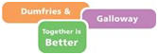
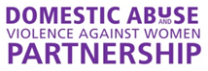

BOOKING FORM
Gender Matters
An open space workshop to explore the cultural and economic issues surrounding gender inequality
Tuesday 6th September 2016, 10am-3pm
Lockerbie Town Hall, Dumfries and Galloway

Your Name

Job title (if applicable)

Organisation (if applicable)
Address

Telephone number

Email

Dietary requirements

Access or learning requirements

Please return completed booking forms to kelseymcgowan@nhs.net by Tuesday 23rd August 2016.
Places will be confirmed by Friday 26th August.

